The Cogito Project
Web-based Room Automation

Brent Strysko

Table of Contents

Introduction …........................................................................................................................................3

Introduction
The Cogito Project aims to create an open source automation platform where anyone can learn new and expand old ideas on automation. All software and hardware used is documented. The project's main components are the power supply, ATMEGA644P microcontroller, and a Dell XPSM1210 running Ubuntu Linux. The power supply is responsible for running the main hub containing the ATMEGA644P chip. The laptop then connects to the board via a usb to serial converter. All devices can be controlled via brentstrysko.com due to the connection the laptop has to the internet.

Power Supply
The power supply used to power the main board is an Xbox360 Power Supply. When plugged in the supply provides 5V along the red wire. When the red wire, which is the active high standby wire, is tied to high along the 5V, 12V is provided along the yellow wires. The black wires are GND. Under proper operation the supply's status light is green. If the main board is drawing more power than it should, such as a short circuit, the status light will turn red.

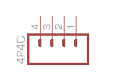
4 – 5V
3 – GND
2 – 12V
1 – GND

Microcontroller
An ATMEGA644P chip is used to interface to all of the projects communication lines. A usb connection is made to the laptop from this chip using V-USB.
Unit Communication
All devices are connected by “4 wire” telephone lines. Below is the standard used to connect devices to the main board.

4 – VCC ( +5V )
3 – Signal 1 (S1)
2 – Signal 2 (S2)
1 – GND (0V)

AC Relays
Type 1 – AC Block Unit Relay
This unit can be interfaced to by plugging devices into the power strip that is built into the unit. Only one out of the two signal lines is used to control a relay. The other line is used to control two signal LEDs.

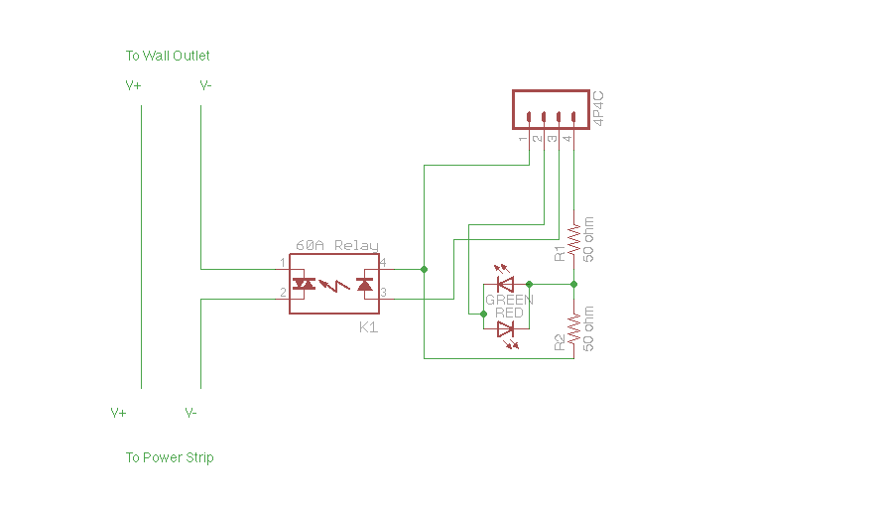
S1
HIGH – relay on
LOW – relay off
S2
HIGH – green led on
LOW – red led on
HIGH-Z(input) – no leds on

Type 2 – AC Unit Relay
This unit can control 3 outputs per given input because of the type of adapter the unit is built on top of. Because there are two relay inputs a total of 6 devices can be controlled. When a relay is on, its respective LED turns on.

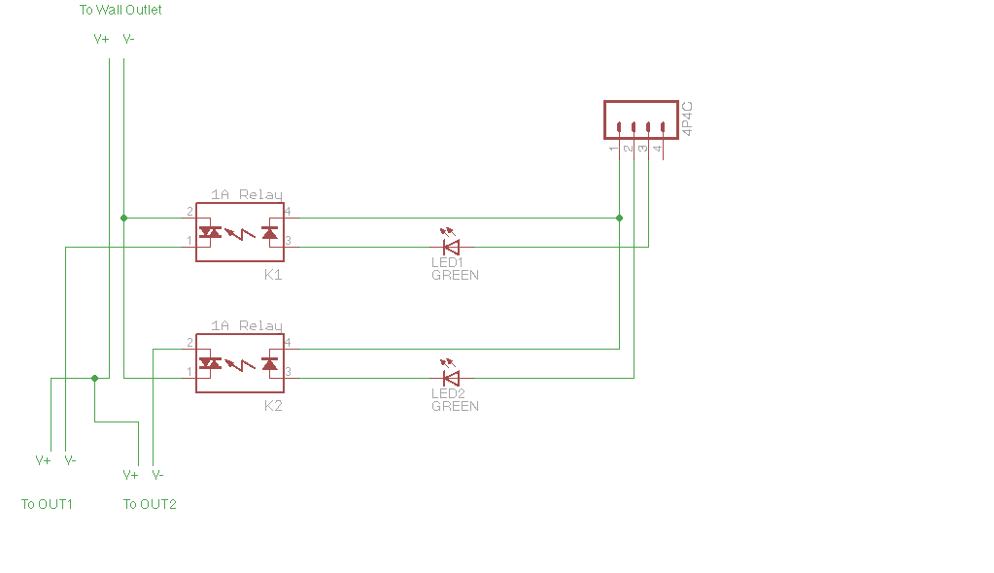
S1
HIGH – K1 on, LED1 on
LOW – K1 off, LED1 off
S2
HIGH – K2 on, LED2 on
LOW – K2 off, LED2 off

50 ohm yellow,brown,black 49.2, 49.6

Ubuntu Desktop Edition on Old Server(drivers are readily available)
relays will be controlled by 555 timers to reduce overload on ports
led strings will use digital pots
Programs will be static and not downloaded at run time
leds will be commonly tied to a transistor on the output of the 555

all ports will be defined as PWR,S1,S2,and GND however the voltage across each port can change based on its specific use/ s1 can be in or out
this is because the breadboard makes it easy to change connections

no lcd will be used, text to speech can reduce overload for that area plus display will also be on screen

lights, temperature, door, blinds

ftp server for music
AC Relays

